Date: 6/1/19 – 10/2019
Location: Johnson Creek Watershed sites
Event length: Approx. 3 hrs/survey
Leaders: Adrienne Moat, Celeste Mazzacano
Partners: JCWC, PP&R, BES
Task: Volunteer Dragonfly Surveys throughout Johnson Creek Watershed
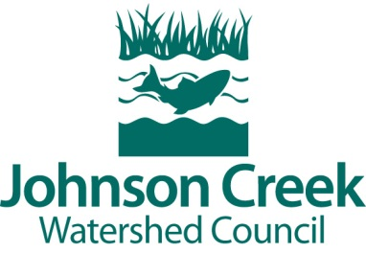

This is a waiver. Please read it carefully. My name below acknowledges that I have read this waiver and hereby agree:

- In connection with my voluntary involvement in activities undertaken for, and with the participation and support of the Johnson Creek Watershed Council, a non-profit organization, and the City of Portland, I hereby agree, for myself, my heirs, assigns, executors, and administrators to release and discharge the Johnson Creek Watershed Council, the City of Portland, Centennial School District, other project sponsors, their members, officers and directors, employees, agents, volunteers, sponsors and landowners from all claims, demands, and actions for injuries sustained to my person and/or property as a result of my involvement in such activities, whether or not resulting from negligence, and I agree to release and hold harmless the Johnson Creek Watershed Council, the City of Portland, Centennial School District, other project sponsors, their officers and directors, employees, agents volunteers, sponsors and landowners from any cause of action, claim, or suit arising there from. I hereby attest that my attendance and involvement in such activities is voluntary, that I am participating at my own risk, and that I have read the foregoing terms and conditions of this release.
- I hereby grant Johnson Creek Watershed Council and the City of Portland the irrevocable right to use forever any film, video tape, audio tape, photographs, slides, or combination thereof, for inclusion in any promotional or advertising purposes and I agree to appear without pay. If I do not want to be photographed, I will inform staff and they will try to accommodate my wishes.
- I hereby agree to use good judgment based on my physical ability and to immediately terminate my participation in the project if activities become too strenuous or difficult; I am physically and mentally fit and able to participate in this project.

Full Name:
Address:
Email:

Signature: ________________________________________________________

Full Name:
Address:
Email:

Signature: ________________________________________________________
Full Name:
Address:
Email:

Signature: ________________________________________________________
Full Name:
Address:
Email:

Signature: ________________________________________________________

